The Need for Speed:

How Qualifying Performance

Influences Race Results

Acacia Johnson
Tarleton State University
BANA 5391 – Business Analytics Research
Dr. Catalin Dinulescu
December 7th, 2025

Abstract
Three different regression techniques will be compared with their predictive accuracy in this report. Multiple Linear Regression (MLR), K-Nearest Neighbors (KNN), and Random Forest Regression (RFR) will be conducted through the use of Python-based machine learning methods. In particular, the relationship between Formula One qualifying performance and final race results are examined using the aforementioned regression techniques. The primary hope of the report is to theoretically contribute by reinforcing model selection frameworks for organizational use cases. The limitations of such models will be discussed in order to refine their effectiveness in future research.
The final regression results indicated that RFR has the strongest predictive performance based on its ability to capture the nonlinear patterns in the dataset. This regression relays an R² value of to 0.4258 in the final model. In comparison, the nonlinear nature of the results creates an R² value of 0.266 for the MLR. The KNN technique offers a middle-ground solution that is sensitive to parameter tuning with an R² value of 0.2857. These values indicated how chaotic and unpredictable an F1 race can be. The RFR is able to approach a predictive accuracy of 50%, which is considered high for the nature of the sport.
Keywords: F1, Predictive Analytics, Grid Position, Multiple Linear Regression, K-Nearest Neighbors, Random Forest Regression

Predicting the Checkered Flag: How Qualifying Performance Influences Race Outcomes
Formula One (F1) is a global motorsport that is known for its data-intensive requirements. Each team must analyze millions of individual data points to optimize the car's performance throughout the entire weekend. This includes the car setup, tire strategy, and fuel management. While external variables can impact a driver’s or a team’s weekend performance, this report will focus on qualifying performance. Qualifying sessions require each driver to set fast lap time to determine their respective starting grid position. The grid order is a crucial component of a driver's race on Sunday. Thus, a high starting grid position is expected to achieve a high final result, making it a central performance indicator. This research examines how strong qualifying performance can predict final finishing position.
Understanding the relationship between qualifying and race outcomes provides crucial insights into explaining which regression models capture performance patterns in F1 data. This is critical information to understand for engineers and analysts within F1. A singular race weekend can create a million data points. This ranges from aerodynamics loads to internal engine temperatures. Being able to accurately predict finishing position impacts race strategy, driver evaluation, and championship results.
To comprehend how deeply the sport relies on analytics, this report will analyze three different predictive models. Multiple Linear Regression (MLR), K-Nearest Neighbors (KNN), and Random Forest Regression (RFR) are the regression algorithms that will provide reliable insights into accurate performance indicators. Each algorithm will be applied to the same dataset to answer the main research question:
Which regression technique most effectively models the relationships in the data and produces the strongest predictive performance?
The following segments will describe the dataset, methodology, regression models, and respective results of each predictive technique.
Problem Statement
The relationship between analytics and performance is crucial for understanding the dynamics in motorsport and for teams to develop strategies. With that in mind, this study addresses the question:
How strongly does qualifying position predict final race results?
Although it is assumed by fans that starting near the front benefits finishing results, this idea has not been evaluated on long-term performance data. This is an anecdotal experience and has not been proven through data analytics. This relationship will be assessed using data from 1950 through 2024. The dataset that will be used within the study is taken from Kaggle. Information about races, drivers, constructors, qualifying, circuits, etc. are included within the dataset. While there are other methods to gather this information, this data set is accurate and compiled for ease of use.
Preliminary Findings and Predictions
Based on viewing the data set, there seems to be a high correlation between grid positions and race results. This study hypothesizes that a driver who qualifies first or second has a greater chance of finishing in the same position. These predictions seek to reflect current reality. Despite widespread race analysis, there are few studies that can explain the connection between qualifying position on final race results across the entire history of Formula One (F1). F1 is currently a ‘qualifying championship,’ where finishing positions are heavily influenced by grid position due to limited overtaking opportunities. In comparison to championships in the 1980s, this sentiment may not hold true. For example, Circuit de Monaco is won by 95.35% of drivers on the starting row. These established patterns are vital for assessing the hypotheses in the next phase of analysis.
Theoretical Contributions
My main purpose of conducting this study is to understand the concept of ‘qualifying performance.’ This is the degree of how crucial grid position is to a finishing outcome. From a theoretical standpoint, the data analysts of each team should be able to predict how optimized the car is for each circuit. With the amount of gathered and processed data within a race weekend, abnormalities in performance will be detected in advance. This research strives to contribute to theoretical literature in three ways. First, it validates the Predictive Modeling Theory. Second, it confirms the Model Comparison Framework. Third, it supports Feature Influence theories. The results established in this study should reinforce how machine learning techniques outperform linear techniques when the model contains nonlinear data.
Accuracy is emphasized by the Predictive Modeling Theory by estimating outcomes, and the Model Comparison Framework evaluates multiple algorithms with similar conditions. The evaluation of the Multiple Linear Regression (MLR), K-Nearest Neighbors (KNN), and Random Forest Regression (RFR) models demonstrate their respective key strengths. The methodological literature that each technique is based upon will also be improved. Finally, the concept of feature importance highlights how certain predictor variables impact the target variable and each individual model. Nonlinear models will gain an increase in performance with utilized in techniques like RFR. Finishing results are shaped by the interactions between variables and justified by the Feature Influence Theory.
Practical Contributions
From a practical standpoint, there are three key implications that could be taken from this research. The first implication focuses on how model selection guidance helps analysts and decision makers determine which models are effective for a respective dataset. Nonlinear or high-dimensional characteristics should be taken into consideration when choosing the appropriate modeling technique. Secondly, the MLR, KNN, RFR model’s expected performance levels are compared and applied in real-world applications. Any result established within this study can improve the prediction power of analytical tools used within Formula One. The third and final implication concerns real-world decision making. The models and techniques established in this research can guide policy decisions and impact racing strategies.
Literature Review
As the demand for machine-learning within Formula is required for competitive advantage, identifying foundational research is vital. This research utilizes three pieces of literature to form a foundation for research. Each piece of literature has contributed significantly to the research of machine learning in sports. These include works written by Bunker and Thabtah (2019) on sports result prediction, Loreto García Tejada (2023) on Formula One (F1) machine-learning techniques, and Weissbock and Mills (2025) on predictive power of qualifying performance. In addition, certain elements of race results are analyzed to determine their effectiveness on race performance. Both machine learning and statistical prediction are key elements to answering the problem statement.
As highlighted in the preliminary section, F1 is a sport that requires substantial attention towards car performance. Teams must consider the independent variables that affect the race weekend. For a team and driver to execute optimal weekend performance, each variable needs to be fine-tuned and optimized for efficiency. For example, adjusting a front wing angle by 1% can drastically impact on the car’s aerodynamic performance. Following the recommendations made by the data analysis team, driving to an optimum level, and executing pit stop strategy are required for peak race execution. Understanding these elements is crucial to recognizing how performance variables operate in F1. Independent Variables such as the number of pitstops, driver age, and circuit location can all be model statistically bason on the subsequent studies.
Bunker and Thabtah (2019) developed a machine learning framework for sports result prediction. The framework used classified modeling to forecast potential outcomes. There is an elevated appreciation for data preprocessing, feature selection, and model interpretability within providing an accurate predictive analysis. While the research was generalized for all major sports, the framework provided an exceptional foundation for applying supervised learning to sports analytics. Their emphasis on feature selection and preprocessing will directly influence this analysis’s data structure. The study also stressed how datasets and transparent modeling can expose unknown relationships between performance indicators and results.
Building on this, Loreto García Tejada (2023) focuses on machine learning techniques that are specified to F1. In particular, the literature forecasts race outcomes, using general race data to identify that qualifying position is incredibly important. It also noted how other external factors produce variability towards a final race result. These factors include tire strategy, safety cars, and weather conditions that vary at each circuit. Predictive modeling is shown to be a feasible indicator of performance but fails to predict long-term results. Its accuracy is unable to capture long-term results due to high variability in races. Garcia Tejada’s research sets a foundation on how qualifying results affect performance but does not explain how this varies across different circuits or historical eras.
The third and final study is a recent report written by Weissbock and Mills (2025). The primary purpose of this research study is to measure the “predictive power of qualifying performance during F1 Grand Prix events”. The findings present within the report show a “strong positive correlation between qualifying and finishing positions” on circuits with limited overtaking opportunities. Since this research was conducted recently, it was found that the aerodynamic regulations currently in place have warped the relationship between qualifying performance and race results. Overtaking is now encouraged on certain circuits where ’dirty air’ (air flow produced from one car to another) is minimal.
Each study highlights the importance of predictive modeling in F1 while showing the key limitations of previously conducted research. Limited historical analysis and a lack of circuit specific analysis will be addressed in this study. While Bunker and Thabtah established a foundation for machine-learning, García Tejada applies this framework to F1, and Weissbock and Mills focus on the new 2022 aerodynamic regulations. This research report adds to the greater conversation by using different methodological and contextual circumstances. The study will consider differing circuits, teams, drivers, and use all past data available. This will produce a historical statistical analysis that bridges the gap between vague predictive modeling and circuit-specific performance interpretation.

Methodology
Data Sample and Measures
Data Collection
This dataset uses all officially known information provided by the Fédération Internationale de l'Automobile (FIA) and Formula One Group. Information such as races, drivers, constructors, qualifying, circuits, lap times, pit stops, and championships are compiled and organized by year. Rohan Rao, the maintainer of the dataset, is a data scientist located in India. This collection of data is available from Kaggle as a CSV formatted file and consists of race entries from 1950-2024. Due to the wide berth of statistics presented, there are multiple tables for the aforementioned data. These tables are linked through the use of unique identifiers like raceID, circuitID, and driverID. To accurately view and analyze the entire file, the data cleaning and merging process will use the Pandas module in Python.
Data Sample Description
To make the historical dataset ready for analysis, a multistage preprocessing method was implemented. Preprocessing involves cleaning, integrating, transforming, and reducing the dataset into an easily accessible file for further analyses. Data cleaning in this instance will correct any inconsistencies within the dataset. The main objective is to remove errors that can distort model performance, whether by using a simple imputer to insert an average mean of each column into the missing values or by simply removing the observation. This process also removes any duplicate data points to ensure that each entry is relevant to the study.
After cleaning comes integration, where each CSV is combined using unique identifiers. The unique identifiers will help merge the multiple datasets using the Pandas module. Transformation ensures that each CSV is readable for analysis by standardizing the numeric and categorical values present. This process is typically managed by the StandardScaler. The reduction stage focuses on the number of entries used in the analysis process, and its primary objective is to select relevant data while removing irrelevant entries.
Based on preprocessing, the original dataset included 26,759 observations, then was reduced to an average 18,000 race entries per regression model. This number varies across models due to differing feature requirements and missing-value patterns. Since older seasons can cause distortions in the model results, this process is crucial for model performance.
After preprocessing, the study uses a filtered dataset and a focus set of variables. Grid is the core predictor variable and states the grid position earned within the qualifying performance. Other independent variables include the constructor, driver, and circuit. The dependent variable is Position Order and is the finishing position for each driver in each race. The key variables selected for this study are summarized below:
Variable Name | Original Dataset | Variable Type | Description
resultID | From results.csv | Integer | Unique identifier for each final result
raceID | From races.csv | Integer | Unique identifier for each Grand Prix
year | From races.csv | Integer | Year of the Grand Prix
round | From races.csv | Integer | Round number in the given season
circuitID | From circuits.csv | Integer | Unique identifier for each circuit
Country | From circuits.csv | String | Circuit country (e.g., Japan, USA)
Location | From circuits.csv | String | Circuit location (e.g., Okayama, Austin)
driverID | From drivers.csv | Integer | Unique identifier for each driver
Driver Ref | From drivers.csv | String | Driver identifier (e.g., “hamilton,” “vettel”)
constructorID | From constructors.csv | Integer | Unique identifier for each constructor
Constructor Ref | From constructors.csv | String | Constructor identifier (e.g., “alpine,” “mercedes”)
Grid | From results.csv | Integer | Driver’s starting position after qualifying (1 = pole position)
Position Order | From results.csv | Integer | Driver’s official finishing position (1 = winner)

Descriptive Statistics
I have created an importable descriptive statistics module within Python. This module uses Pandas to identify key statistics such as mean, median, and standard deviation. Its primary purpose is to ensure the statistics are consistent and automated across the entire CSV. The module stores this information within a dictionary and converts it into a data frame with rounded values. According to this module, 51% of drivers finish within five places of their starting position. This suggests a strong correlation between qualifying and final outcomes. These trends vary by circuit. For example, circuits like Monaco and Spa-Francorchamps reward strong qualifying performances in comparison to tracks like Fuji Speedway or Jeddah Corniche Circuit. The descriptive statistics for the final results are as shown below:
Statistic | Qualifying Position | Finishing Position
Mean | 11.808 | 12.794
Median | 11.00 | 12.00
Standard Deviation | 6.621 | 7.666
Variance | 43.839 | 58.767
Skewness | 0.235 | 0.399
Kurtosis | -0.739 | -0.474

Construct Measurement
To formally answer the proposed research question, we must determine how to measure the selected constructs. Qualifying performance’s operational definition is a driver ranking from a set of speed trials the previous day. This is measured by Grid, the continuous, ordinal, and numeric independent variable. The next construct is the dependent Position Order, a continuous ordinal numeric variable. It is the final result or outcome, referred to as race performance, for each driver in an individual race. The final construct is Circuit Name. The measurement variable has the same name as a construct and is a nominal categorical variable. The main purpose of these constructs is to analyze how qualifying performance predicts race results varies across different circuits and constructors.
Data Analysis
Methodology
The entire analysis uses predictive analytics and machine-learning techniques to determine the strength of starting position as a predictor of final finishing positions. The essential principles that heavily influence this report are Multiple Linear Regression (MLR), Random Forest Regression (RFR), and K-Nearest Neighbors Regression (KNN). MLR improves upon the established simple linear regression by including additional variables (Kutner et al., 2005). For example, the country of each circuit or the constructor of each driver can predict the final race result. The proposed equation for this method is:
$$FinalPosition=β0​+β1​(QualifyingPosition)+β2​(Controls)+ϵ$$
These additional factors can explain why certain drivers can score a race win from lower qualifying positions than other drivers from different constructors.
The machine learning portion of this analysis uses RFR as a non-linear model. The concept of feature importance will place priority on qualifying position and compare it to other factors within the MLR. A random forest is chosen because it works well with mixed data types, such as categorical and numerical variables. It provides generalization for the finishing outcome using feature importance because “…their correlations gives insight into the ability of the random forest to predict” (Breiman, 2001).The random forest can also manage non-linear relationships, which is vital for connecting circuit locations to race results.
KNN Regression is the final method that will be used to determine how qualifying position predicts final finishing outcomes. It is useful for viewing non-linear relationships and local circuit characteristics. “Nonparametric regression techniques are flexible, powerful methods for estimating an unknown regression function” (Altman, 1992). This method is relevant because F1 performance is nonlinear. There are certain performance patterns specific to each circuit, and it is robust against potential outliers.
Justification
Regressions were chosen for this study because they provide quantitative direction, interpretability, replicability, and predictive modeling. The use of three different data analysis methodologies allows for circuit-level comparisons using machine learning algorithms. This approach focuses on fully explaining the results of the research question. The main objective is to understand the predictive strength of qualifying position rather than optimizing predictive accuracy. By using linear and nonlinear methods, I will be able to effectively demonstrate how starting positions predict finishing results across all circuits.
Plan
There are five main phases for this project. The first phase focuses on data preparation. All Kaggle tables and databases are loaded into the Python program, then perform the steps mentioned in the Data Sample Description section. Each database is merged into their respective data frames, inconsistent data is removed, and missing data is supplemented. The second step in the data preparation phase is to define the variables. Grid, or the qualifying position, is used as the independent variable, while Position Order, or final race result, is selected as the dependent variable.
The second phase focuses on feature training. Each methodology is tuned differently. The MLR needs to be checked for linearity, homoscedasticity, and multicollinearity assumptions. This is to ensure the model is operating efficiently without error. Each K value within KNN needs to be set to a specific value, such as 5, 10, or 20. This is a vital step in training the classifier used within this methodology. RFR also needs its parameters trained. The estimator, maximum depth, maximum features, and sample splits all need to be defined in preparation for phase three.
Phase three focuses on training the entire model. An ordinary-square regression is fitted on the MLR, distance metrics are tuned for KNN, and cross-validation is determined for RFR. This is a fairly simple step where each method serves as the setup for phase four, model comparison. I will evaluate each model’s performance using primarily variance (R²), Mean Absolute Error (MAE), and Root Mean Square Error (RMSE). Variance is also applicable to each model, while MAE and RMSE are only usable with KNN and RFR.
The fifth and final phase is to focuses on explanation through visualization. This involves the creation of scatter plots, feature importance charts, and coefficient tables. Each circuit will have its performance compared to another to predict the importance of qualifying position in relation to the final finishing outcome. The RFR will take this a step further by concentrating on feature importance of the main independent variable (qualifying position) relative to other factors.
Analytical Hypotheses
There are three expected results from this study. The first is that there will be a strong correlation between qualifying and finishing positions across all street circuits. A prime example of this is the Circuit de Monaco. This circuit has been around since the inception of F1 and is known for its tight corners and narrow roads. It is incredibly difficult to gain or lose positions in every era of Formula One. My second expected result is that high-speed circuits provide chances for overtaking and better racing. Circuit of the Americas (COTA) is a purpose-built racing track for all categories of motorsports. It was built in 2012, and its main purpose is to promote overtaking at high speeds for spectators. My third and final expected result is that there is a gradual increase in predictive strength over time. Modern regulations focus on individual car performance rather than racing within the series. Mechanisms such as the drag-reduction system (DRS) and tire-strategy changes make each weekend fairly predictable once these factors are officially known.

The Results
Multiple Linear Regression
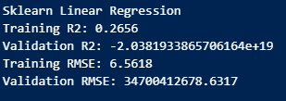
As mentioned in the Data Analysis Methodology section, the multiple linear regression model seeks to understand how position order is affected by grid position and other independent variables. To fully understand how this model operates, a linear regression is used from the scikit-learn library, and another from the StatsModels library. The primary predictor variables analyzed are grid, driver age, year, round, fastest lap speed, constructor, circuit location, and circuit country. Only the constructor’s name, circuit location, and circuit country were converted into dummy variables since these columns do not contain numeric values.

I set up the scikit-learn library to print the training and validation R² values and Root Mean Square Errors. These statistics will be compared against other methodologies in the following sections. After performing MLR, the results indicated that the data contained multicollinearity, contained too many predictors, and contained too many dummy variables. This is partially due to the sheer number of constructor names and circuit combinations with locations. For reference, there are 215 predictors for 18,731 observations. This number needs to be consolidated to realistic maximum of ten predictors for the regression to succeed.
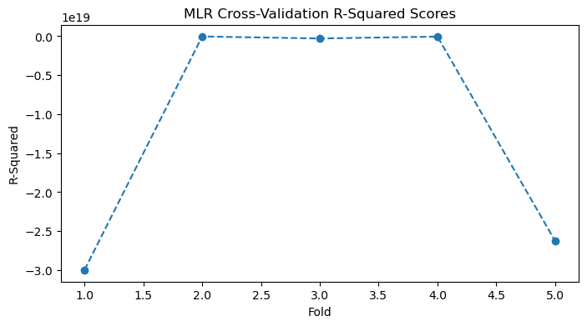
The results are complemented by the cross-validation R² scores. Based on the graph produced, the 5-fold CV scores are -2.99824470e+19, -3.34164453e+16, -2.94157399e+17, -5.00886096e+16, and -2.62803456e+19.
The cross-validation produces a mean R² of -1.1328091010049305e+19. These values indicate that the model is a poor predictor for the mean finishing position. There is an abnormally large variance between each individual fold, and the mean R² value indicates that the model cannot generalize across folds.
There are three potential fixes for these issues. The first is to reduce the number of constructors. This entails combining multiple variables into assigned categories. Teams like McLaren have had multiple title sponsors over the history of the sport. The data set separates each one of these sponsor names instead of consolidating them per team. Merging all available constructor data into the 2024 teams will reduce the number of predictors. The same methodology applies to circuits and locations.
The second potential fix is to remove some of the dummy variables in the regression. Each constructor, circuit location, and circuit country have dummy variables assigned. This creates hundreds of empty columns that slow down and bloat the regression model. The third and final potential fix is to ensure the training/validation split its operating efficiently. Data leakage from the sheer number of observations can skew the results received from the regression.
K-Nearest Neighbors Regression
The K-Nearest Neighbors regression is fairly similar to random forest regression. This method follows the steps of creating an initial model, improving it, and producing a final model performance score. The initial model produces an R² value of 0.2066, or approximately 21%. This means that the current KNN model explains how starting position determines finishing position 21% of the time. The parameters that explain this initial R² value use a uniform weight and five neighbors.
The grid search tunes the initial model by selecting specific values for the maximum depth, sample split, and impurity decrease. In combination with a cross-validation score of five folds, the model is able to explain 0.2857 of all finishing positions. The final random forest model takes the best parameters established previously, fits them on the training model, and predicts what the validation model is. The R² value has improved to 0.2859, produces an RMSE of 6.4799, and an MAE of 5.2328. In reference to F1 race results, this means that the model is able to predict the finishing position within 5.2 grid places. This is a weak performance indicator, considering that the model is unable to comprehend the multidimensional numeric and dummy variables.
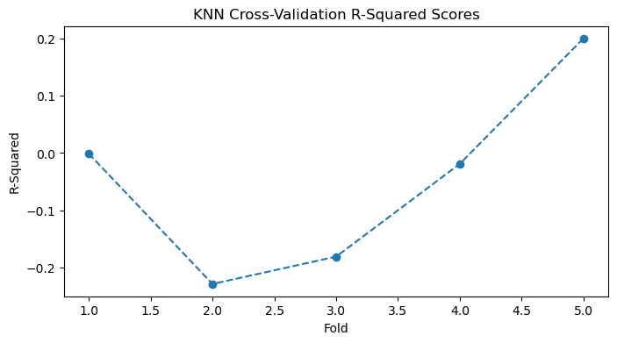
While this model produces a better result than the multiple linear regression, it is unable to capture the accuracy of the random forest model. It struggles with creating a consistent and stable result with low variation. The KNN model is also unable to account for distances or locations within the data. The regression is also unable to manage the sheer number of predictors within the dataset. This reduces its compatibility with the random forest model despite performing at a lower tier level.
These results are complemented by the cross-validation R² scores. Based on the graph produced, the 5-fold CV scores are -0.00118946, -0.22812077, -0.18045498, -0.01880178, and 0.19982046. These scores produce a mean cross-validation R² of -0.0457. These values indicate that the model is a poor predictor for the mean finishing position. There is a large variance between each individual fold, and the mean R² value indicates that the model cannot generalize across folds.
Random Forest Regressors
The random forest regressor uses the same data preprocessing methodology as the other two regression models. In this instance, we will focus on creating an initial random forest model and refining it through a grid search. The initial model produces an R² value of 0.4188, or 42%. This means that the current forest model explains how qualifying position determines finishing position 42% of the time. The parameters that explain this initial R² value include a maximum depth of six and 300 estimators.
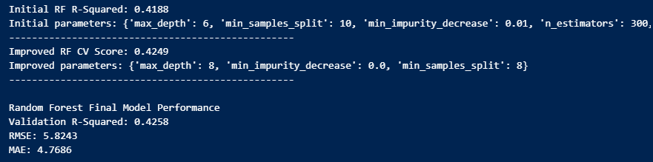
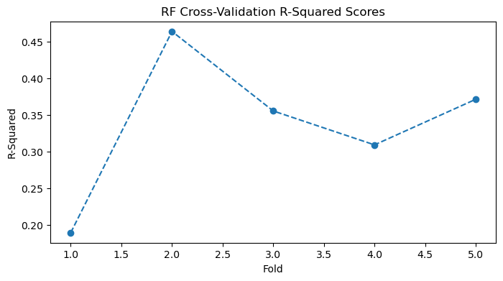
The grid search tunes the initial model by selecting specific values for the maximum depth, sample split, and impurity decrease. In combination with a cross-validation score of five folds, the model is able to explain 0.4235 of all finishing positions. The final random forest model takes the best perimeters established previously, fix it on the training model, and predicts what the validation model is. The R² value is improved to 0.4258, produces an RMSE of 5.8243, and an MAE of 4.7686. In reference to F1 race results, this means that the model is able to approximately predict the finishing position within 5 grid places. This is an impressive performance indicator considering that races are often random, chaotic, and unpredictable.
The results are complemented by the cross validation R² scores. Based on the graph produced, the 5-fold CV scores are 0.18958647, 0.46376299, 0.35538117, 0.30919038, and 0.3713031. The cross-validation produces a mean R² of 0.3378. These values indicate that the random forest is able to generalize predictions across each fold. A positive signal is produced, and each finishing position is explained within the demonstrated variance. The model depicts an accurate representation of real-world events.
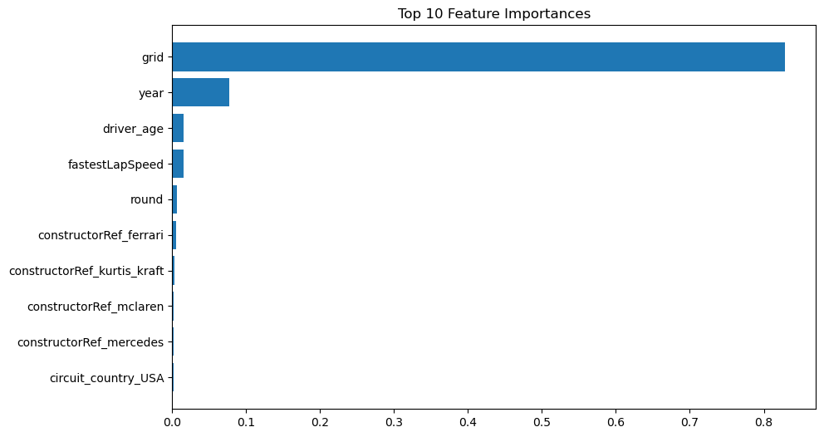
The result received could be further elaborated for finishing position if additional data, such as lap times and pit stops were included in the regression. In addition to determining the model's performance, a feature importance simulation is conducted. This simulation identifies the top 10 important variables and their respect to finishing position. Based on the graph created, qualifying position explains over 80% of the variance in finishing results. The second most important feature is the year of each race. For example, races conducted in the 1960s were marred by unpredictable and often deadly race results. In comparison to the modern era of Formula One, finishing positions are relatively close to, and often the same as, qualifying results.
Results Discussion
Multiple Linear Regression
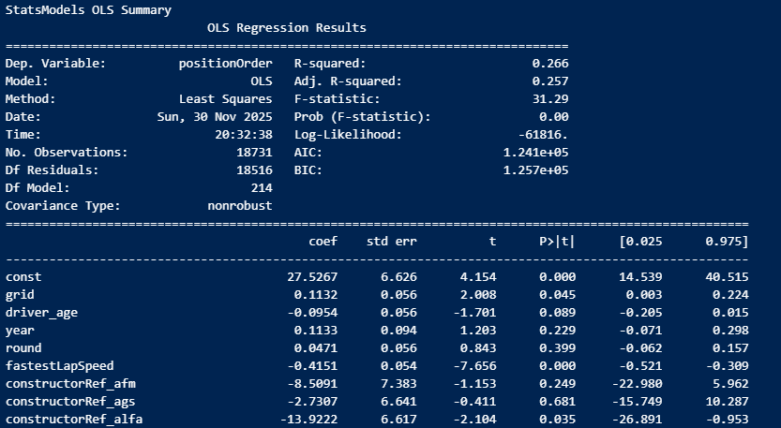
There are several key insights that can be gained from the Multiple Linear Regression (MLR), K-Nearest Neighbors (KNN), and Random Forest Regression (RFR) models. The predictive relationships established in the dataset create differing results based on each model. For the MLR model, the relationship between the predictor and target variables reflects one major idea: that there are no direct linear relationships in the dataset. The model has an F-statistic of 31.29, which indicates that the regression is highly statistically significant (p < 0.001). This also means that based on the sheer number of observations, individual results can sway the model in a positive or negative direction.

The next section will analyze the top five predictor variables in the model. Qualifying performance has a coefficient of 0.1132 and a p-value of 0.045. Our main testing predictor is statistically significant, but this is a lower value than other variables. This result can be interpreted as a worse qualifying position becoming a worse finishing position. For example, a driver loses 0.11 places on average for each additional grid spot earned.
The next predictor variable is driver age. It has a coefficient of -0.0954 and a p-value of 0.089. This is not a statistically significant variable with a p-value requirement of 0.05. That is expected based on the average age of Formula One drivers and the experience needed to perform well. A prime example of this is Fernando Alonso. He is a current driver for Aston Martin and also the oldest driver in the sport at the age of 44 years old. He has won the World Driver Championship (WDC) twice and is known for his ability to produce excellent results. On the opposite side of the spectrum, Kimi Andrea Antonelli entered the sport at 18 years old with Mercedes as a newcomer in 2025. At the conclusion of the 2025 championship, he is ranked seventh in the WDC compared to Alonso’s tenth position. If this variable were to be statistically significant, older drivers would finish higher/better than younger ones.
The third variable we will discuss is the year of the race. It has a coefficient of 0.1133 and a p-value of 0.229. The year has no significant value in reference to the model, and there is no difference between finishing a race in fifth position in 1995 or in 2025. The same is true for the race round in each season. Round has a coefficient of 0.0471 and a p-value of 0.399. Finishing a race in the first round is no different from finishing a race in the last round.
The strongest and most important predictor is fastest lap speed. This variable has a coefficient of -0.4151 and a p-value of 0.001. The faster a driver can complete a lap, the lower the finishing position will be. For every kilometer the driver drives faster, the finishing position will improve by 0.42 places on average. This is to be expected since cars with more pace and better engines tend to finish in higher rankings.
Overall, the model provides insight into explaining 27% (an R² value of 0.266) of all race results. This is a humble result due to the unpredictable nature of racing. There are numerous external factors that can affect race results, such as incidents, safety cars, and pit strategies. The main takeaway from this model should be that qualifying performance is important but maintaining a fast lap speed leads to finishing the race faster. Additional predictors like driver age, year, and round are not meaningful in the greater scope of F1 racing.
K-Nearest Neighbors
For the K-Nearest Neighbors (KNN) model, the relationship between the predictor and target variables reflects that this is not the best technique for the dataset. The initial KNN model is able to explain 20.7% of the variance with a uniform weight, five neighbors, and the ‘Minkowski’ metric. This baseline model has minimal predicting power and is similar to the MLR algorithm. By conducting a Grid Search, the model is improved by using a distance-based weight, 15 neighbors, and the ‘Manhattan’ metric. The improvements reduced variance and increased the R² value to 28.5%. In the final model, the validation set improved the R² value by 0.4%. The root mean squared error (RMSE) indicates that a prediction may be incorrect by 6.5 finishing positions, while the mean absolute error (MAE) indicates that inconsistencies are typically off by five finishing positions.
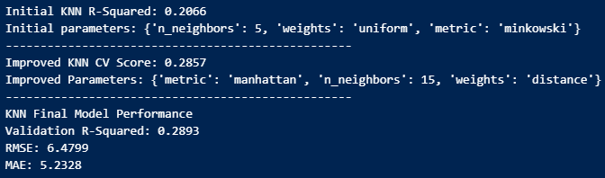
While the final model was able to explain 28.9% of all race results, the cross-validation performed poorly with a negative mean R² value of -0.0457. This means that the model is unable to correctly predict finishing positions in 4 of the 5 folds selected. This issue could be caused by overfitting the training/validation split, an uneven distribution between the folds, or noise within the predictor variables. My educated guess is that the sheer number of dummy variables for circuit countries and locations may be interfering with overall performance.
Random Forest Regression
The Random Forest Regression (RFR) model is the best-performing technique out of the trio. It is able to correctly predict 42.6% of all finishing positions and has a strong mean cross-validation score. The final tuned model is trained on the validation set, uses a maximum depth of 8, and a minimum sample split of 8. Therefore, more complex nonlinear interactions are found within the deeper, flexible trees.
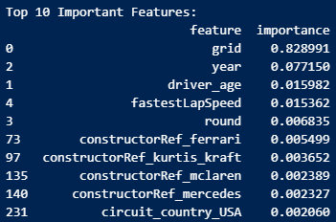
The root mean squared error (RMSE) indicates that a prediction may be off by 5.82 finishing positions, while the mean absolute error (MAE) indicates that inconsistencies are typically made by 4.77 finishing positions. For a high-variance sport such as F1, this is a highly accurate prediction model. In contrast to the MLR technique, the most important predictor variable is qualifying performance (grid). This predictor has an importance score of 0.82899. The next highest feature is year at 0.007715. This suggests that grid position is 83% of the model’s predictive power. In reality, drivers starting in lower grid positions are unlikely to win the race.
The final component of this model is cross-validation. All five folds contain positive values that are consistent with the established R² value. Despite the variance between each fold, the model is able to generalize the racing data with a mean R² of 0.3378. This is an impressive performance indicator in comparison to KNN. Based on the RFR, race results are dependent on qualifying performance more than any other predictor variable. This nonlinear model is able to outperform the others in every aspect possible.
Limitations and Future Research
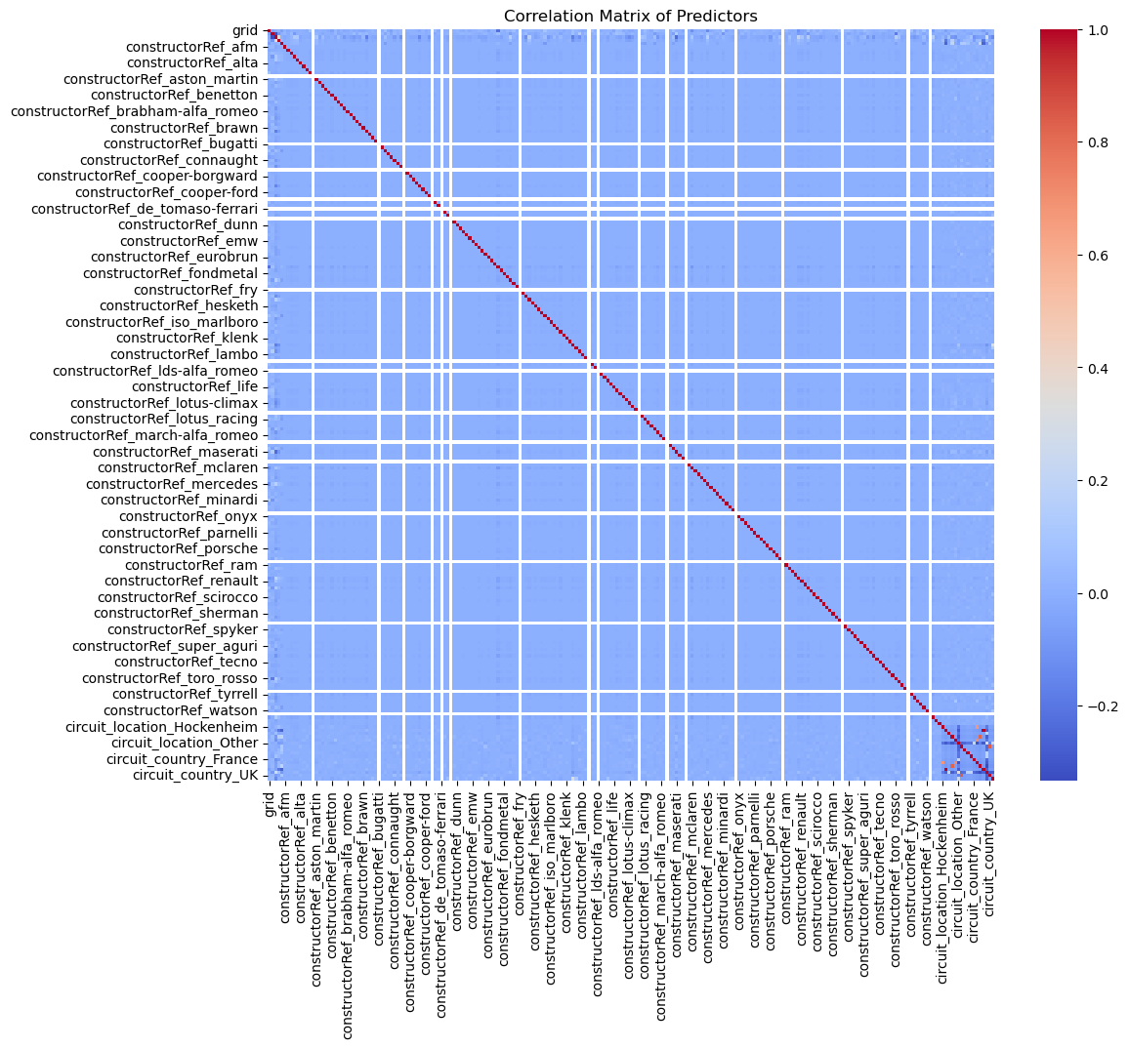
The overall model performance from each technique heavily relies on data quality and completeness. Each entry needs to be fully completed to be considered a part of the dataset. After inspecting the K-Nearest Neighbors model, the sheer scale of the dataset and dummy variables negatively impacted the results. This model should have removed all dummy variables to reduce the number of predictor variables in the analysis. Different preprocessing techniques could be used to further shrink the number of observations included in the model. Another limitation of this research is that the Multiple Linear Regression model assumes linearity, normality, and homoscedasticity. This may not be true due to the number of variables included in the model. Based on the correlation matrix, the dummy variables for circuit locations and circuit countries are highly correlated. The solution to this problem would be to remove either variable group.
For future research purposes, the use of different advanced models like neural networks would be beneficial in establishing deeper comparisons between the predictor and target variables. The number of years included in the dataset would also be limited. Formula One has been around for 75 years and has amassed over 26,000 observations. By shrinking the data to a particular time period, the study can focus on the regulations and rule sets that affected the drivers and constructors. By capitalizing on time based variables, a time series model could also be implemented in the analysis. Another potential research idea would be to implement dimensional reduction strategies that can improve performance optimization.

Conclusion
This research has examined how the Multiple Linear Regression (MLR), K-Nearest Neighbors (KNN), and Random Forest Regression (RFR) models perform in predictive modeling situations. The primary purpose of this research was to determine which modeling approach can best understand and explain qualifying performance and final race results. The final conclusions indicate that MLR is efficient in examining linear relationships but is unable to properly determine nonlinear factors. The KNN is able to understand how nonlinear patterns affect the target variable, finishing position, but it is extremely sensitive to scaling and selected parameters. The model with the best overall performance was RFR. It was able to accurately predict finishing position while correctly modeling nonlinear interactions and feature importance.
From a theoretical perspective, the model selection results established are able to reinforce machine learning techniques for complex datasets. In contrast, analysts and organizations will be able to use actionable guidance in a practical manner and implement predictive analytics. This research is able to expand the concepts of theory and practical applications with the help of machine learning regression models in a comparative framework.
Discovered results from each prediction model were as expected. Both of the MLR and KNN models under performed for this dataset, whereas the RFR model excelled at answering the research question and problem statement. As for significance in the field of predictive analytics, multidimensional data should be analyzed using the Random Forest Regression model. Its ability to leverage feature importance and generate accurate predictions is valuable for large datasets such as this one. These advantages make the RFR model the strongest at effectively modeling the relationships in the data and producing the strongest predictive performance from the three presented models.

References
Altman, N. S. (1992). An Introduction to Kernel and Nearest-Neighbor Nonparametric Regression. The American Statistician, 46(3), 175–185.
Breiman, L. (2001). Random Forests. Machine Learning, 45(1), 5–32. https://doi.org/10.1023/A:1010933404324
Bunker, R. P., & Thabtah, F. (2019). A machine learning framework for sport result prediction. Applied Computing and Informatics, 15(1), 27–33. https://doi.org/10.1016/j.aci.2017.09.005
Garcia Tejada, L. (2023). Applying Machine Learning to Forecast Formula 1 Race Outcomes. https://aaltodoc.aalto.fi/handle/123456789/122937
Kutner, M. H., Nachtsheim, C. J., Neter, J., & Li, W. (2005). Applied linear statistical models (5th ed.). McGraw-Hill/Irwin.
Weissbock, J., & Mills, S. (2025). Evaluating the Predictive Power of Qualifying Performance in Formula One Grand Prix (No. arXiv:2507.10966). arXiv. https://doi.org/10.48550/arXiv.2507.10966

Programming Scripts
Master F1 CSV
Descriptive Stats Module
Multiple Linear Regression
K-Nearest Neighbors Regression
Random Forest Regression

